In this model, for K=3, I have shown predition results, silhouette scores, and cluster centers.

Training model with K=3 for predictions:

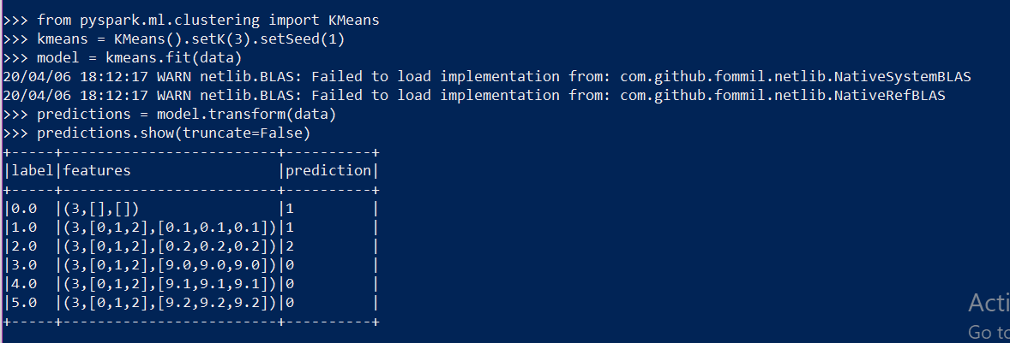

**Prediction Results**: Here, we see that we defined K=3, so we have clusters “1, 2, and 0” in the prediction column. The first two rows belong to the cluster ‘1’, the third row belongs to the cluster ‘2’. The last three rows belong to the cluster ‘0’.

Changes from the original example are that we previously used K=2, and saw only cluster “0” and “1”. Two clusters. With K=, we now see three clusters, “1”, “2”, and “0”.

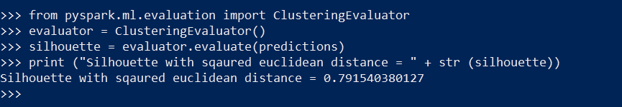

**Silhouette Scores:** This is a value that is relatively close to 1, which means that the points in a respective cluster are close to othe other points in the same cluster and relatively further away from the points of the other cluster.

Changes from the original example are that with K=2, the silhouette was 0.99…. and here, it is 0.79. Which means that using with K=2, values are much closely clustered together. When we increase the number of clusters to K=3, the arrangement of data points is not as tight-knit/compact within the custer and is farther from each cluster in comparison to K=2.

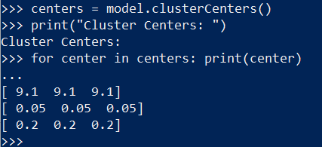

**Cluster Centers:**

[9.1 9.1 9.1] is the center of the cluster “1”,

[0.05 0.05 0.05] is the center of the cluster “2”,

[0.2 0.2 0.2] is the center of the cluster “0”.

Changes from the original example using K=2, is that onw we have three cluster centers resulting from using K=3. The number of centroids have increased from 2 to 3.